**Project Design Phase**

**Solution Architecture**

|  |  |
| --- | --- |
| Date | 19-02-2026 |
| Team ID | LTVIP2026TMIDS66321 |
| Project Name | Cafeteria Menu Display |
| Maximum Marks | 4 Marks |

**Solution Architecture:**

* Identifies cafeteria issues such as outdated menus, customer confusion, and high staff workload.
* Proposes a centralized digital menu display system as the best technology solution.
* Includes an admin/dashboard application for easy menu, price, and availability updates.
* Uses a backend server to process, validate, and synchronize menu data.
* Stores all menu information in a centralized database for consistency.
* Displays real-time menu content on digital screens placed inside the cafeteria.
* Supports network connectivity (Wi-Fi/Ethernet) for instant updates across all displays.
* Defines system features, development phases, and functional requirements clearly.
* Ensures scalability, maintainability, and future integration with billing or mobile systems.

**Example - Solution Architecture Diagram:**

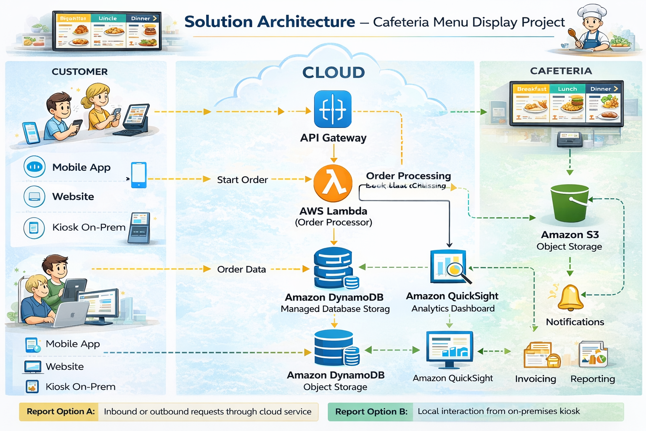

**Reference:** [**https://aws.amazon.com/blogs/industries/voice-applications-in-clinical-research-powered-by-ai-on-aws-part-1-architecture-and-design-considerations/**](https://aws.amazon.com/blogs/industries/voice-applications-in-clinical-research-powered-by-ai-on-aws-part-1-architecture-and-design-considerations/)